Asia-China-Coin-Southern Song-Mould

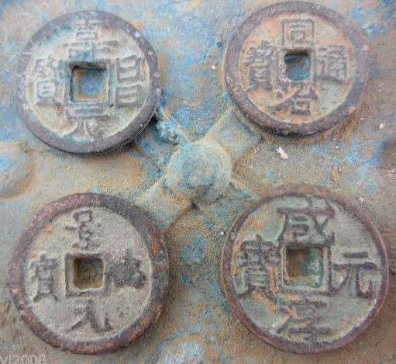

Southern LR H 17.849 R 14

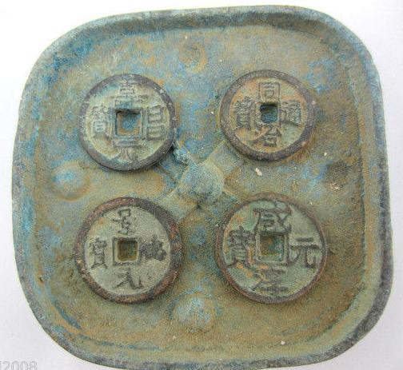 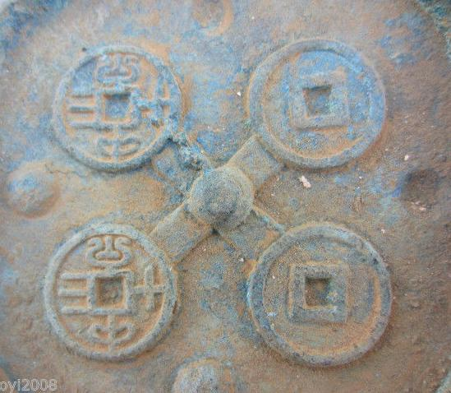 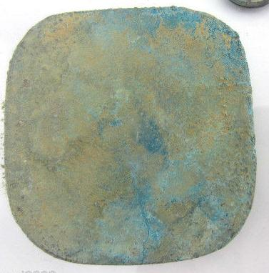

Sold by

[wohexiaoyi2008](http://myworld.ebay.com/wohexiaoyi2008) ( [85](http://feedback.ebay.com/ws/eBayISAPI.dll?ViewFeedback&userid=wohexiaoyi2008)  )

+ Show additional actions

Delivery package 1 of 1

Estimated delivery Wednesday, Jan 8, 2014 - Thursday, Jan 16, 2014

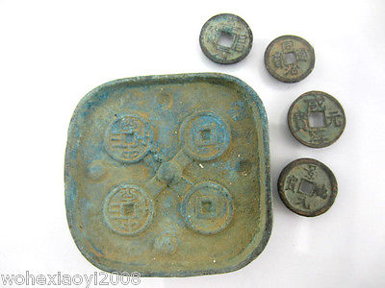

[Antique bronze Mould Used in manufacture coin with four coins bronze currency](http://www.ebay.com/itm/321282277221)

Item price

$17.99

Quantity

1

Item number

321282277221

Shipping service

ePacket delivery from China

[Leave feedback](http://feedback.ebay.com/ws/eBayISAPI.dll?LeaveFeedbackShow&useridfrom=802-867&useridto=wohexiaoyi2008&item=321282277221&transactid=1206444114011) [Contact seller](http://contact.ebay.com/ws/eBayISAPI.dll?FindAnswers&frm=3998&iid=321282277221&redirect=0&requested=wohexiaoyi2008) [Return item](http://return.ebay.com/ws/eBayISAPI.dll?ResolveReturn&eventName=viewSelectedItem&TransactionId=1206444114011&ItemId=321282277221)

### Shipping address

Ralph J Coffman Jr  
149 Atlantic Ave   
Swampscott MA 01907-2427  
United States

Phone number  
781 584 7091

### Order total

Subtotal $17.99

Shipping Free

#### Total

## $17.99

[View PayPal transaction](http://payments.ebay.com/ws1/eBayISAPI.dll?IntermediateResolutionInfo&itemid=321282277221&transId=1206444114011&pn=UnifiedCheckoutSummaryRedirect2PP&qs=itemid%3D321282277221%26transId%3D1206444114011%26buyerorseller%3D0%26)

### Order information

Order placed on  
Saturday, Dec 28, 2013

Having a problem with this purchase?  
[Resolve problem](http://res.ebay.com/ws/eBayISAPI.dll?ResolutionCenter)

Payment method   
PayPal

Payment date  
Saturday, Dec 28, 2013